Supported and Independent Living Services

Aim
To brief stakeholders on information gathered on placement activity for young people (YP) in multi-occupancy group living / semi-independent, floating support with accommodation and floating support placements.

Background
Supported accommodation services are provided for YP who are looked after, leaving care or who present as homeless. YP presenting as homeless may or may not become looked after by the Authority depending upon the outcome of a joint assessment.

Wherever possible placements for 16+ YP are commissioned via existing block contract arrangements or through the regional North West Dynamic Purchasing System. Utilising block purchased provision is a key commissioning priority set out in the Authority's Children Looked After Sufficiency Strategy approved by Cabinet in October 2017.

As the table below shows, Lancashire has experienced a significant increase (143%) in externally commissioned supported accommodation placements for children looked after (CLA). Whilst CLA overall have increased by 13% overall, the proportion in supported accommodation has risen, partially impacted by the homeless protocol. During 2017/18 55 YP aged 16/17 become looked after as a result of the protocol, with varying durations of service)

At 31st July 2018 all supported accommodation placements were commissioned through either block or DPS providers and the proportion is shown below:

 | Number of Looked After Children
 | Jul-18 | Mar-18 | Dec-17 | Sep-17 | Jun-17 | Mar-17 | Dec-16
DPS | 98 | 90 | 84 | 85 | 65 | 61 | 50
Block contract | 31 | 19 | 17 | 15 | 7 | 1 | 3
Total CLA in supported accommodation | 129 | 109 | 101 | 100 | 72 | 62 | 53
Total no. CLA | 2,051 | 1,968 | 1,951 | 1,921 | 1,876 | 1,864 | 1,816
In supported as % of total | 6.3% | 5.5% | 5.2% | 5.2% | 3.8% | 3.3% | 2.9%

Supported accommodation for CLA now represents c.6.3% of the looked after children population and c.10% of the overall placement spend.

Purchasing patterns across the North West region vary significantly as a consequence of different patterns of internal services, supported lodgings, staying put uptake and local block contracting arrangements. Lancashire currently has no in-house accommodation or supported lodging arrangements but the number of YP staying put was reported by Ofsted as being above the national average. As part of the service redesign the option to deliver some services in-house will be considered.

DPS / Off-contract arrangements
Availability, location and how quickly a placement is required all impact on the placement outcome.

In terms of market supply through the DPS:
- Of the 94 DPS group living addresses on the framework 23 were inside of LCC boundaries;
- Supply of group living provision is contained to limited parts of the county: Burnley (7), Accrington (2), Preston (8), Morecambe (4), Fleetwood/Lytham (2) as presented on the map below:

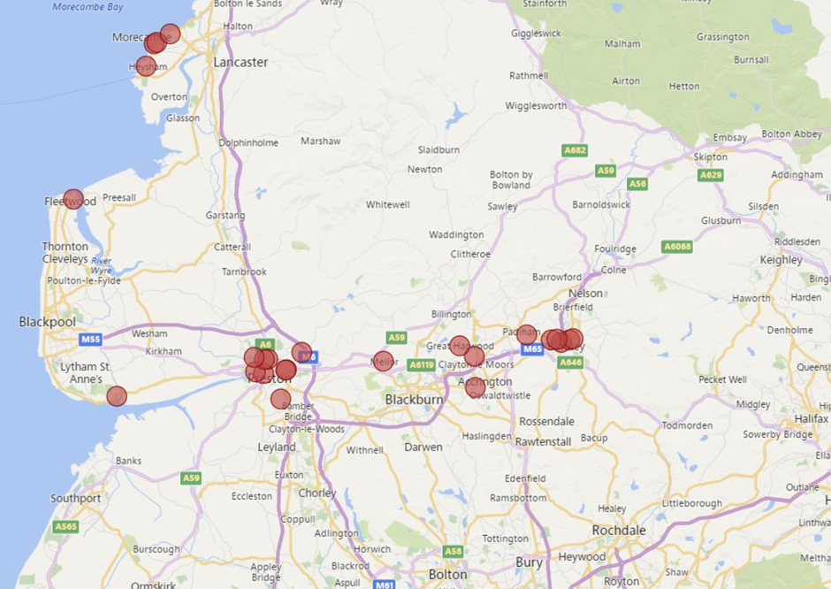

- At 31st March 2018 LCC were commissioning c.45 placements in group-living (3+ bed) settings
- Based on actual bednights at that date the equivalent of 24 beds just in the three areas of Burnley, Accrington and Preston were commissioned

- There are 33 floating support with accommodation (FSWA) providers in DPS North zone;
- Lancashire commission FSWA predominantly in the East, to a lesser extent in Central and very little in the North of the county.

To what degree are the current commissioning arrangements being driven by supply? Has this been a result of LCC not communicating service need and gaps in provision to the market?

Block Contract arrangements
LCC has a number of block (ex-Supporting People) contracts in place to commission accommodation-based core, move-on, and crisis support, along with supported lodging services, teenage parents and combined (YP & families) schemes. A summary of the core and move-on provision commissioned on a district footprint, totalling 249 units, is below:

District | No. Units
Burnley | 22
Pendle | 19
Rossendale | 14
Hyndburn | 11
Ribble Valley | 7
Preston | 27
Chorley | 18
South Ribble | 29
West Lancashire | 10
Fylde | 12
Lancaster | 47
Wyre | 33

The following services are block commissioned on a locality footprint:

Support service category | East | Central | North
Dispersed accommodation | 85 | - | -
Supported lodgings | 13 | - | 9
Teenage parents | 9 | 6 | -
Combined YP / families | 7 |  | 6

Under the Supporting People arrangements the block contracted services were accessed by 16-25 year olds however in March 2017 the decision was taken to limit access to YP aged 16-21 (up to age 24 for former relevant care leavers). Since October 2017 prioritisation criteria applies, with highest priority to 16/17 year old looked after children, care leavers and YP presenting as homeless.

The utilisation of block capacity is generally high across core and move-on services but it is acknowledged that services currently accommodate YP aged 22+ who are not former relevant care leavers and that the introduction of the prioritisation criteria will impact on future demand. Data for Qtr 1 2018/19 is still being collated but the Oct 2017 to March 2018 data showed the proportion of YP commencing a service was split:
  - High priority: 94 (55%)
  - Medium priority: 35 (20%)
  - Low priority: 42 (25%)

As YP aged 22+ move on from the services it is anticipated that the proportion accessed by low priority clients will reduce.

In terms of numbers of YP wishing to access services, for Oct '17 to Mar '18 more than 200 YP aged 16-17 and 260 YP aged 18-21 applied, with services commencing for 112 and 109 YP from the two cohorts respectively. Data for Qtr 1 is currently incomplete but indicate that the number of applications have increased.

Placement finding
Since February 2017 placement searches have been co-ordinated centrally by LCC's Access to Resources Team (ART). The information below is collated on a monthly basis and can be shared periodically with providers:

1) Placement Requests by Area
 | North | Central | East | Total
Feb'17-Mar'18 | 82 | 118 | 80 | 280
April '18 | 5 | 9 | 7 | 21
May '18 | 12 | 17 | 3 | 32
June '18 | 12 | 19 | 17 | 48
Total | 111  (29%) | 163  (43%) | 107  (28%) | 381  (100%)

In terms of actual supported accommodation placement starts in the most recent quarter April-June 2018, 52% were from Central teams, 40% from East and 8% from North.

2) Placement Requests by District
 | Feb17-Mar18 | Apr-18 | May-18 | Jun-18 | Total | %
Burnley | 25 (9%) | 2 (10%) | 0 (0%) | 6 (13%) | 33 | 9%
Chorley/South Ribble | 40 (14%) | 1 (5%) | 4 (13%) | 8 (17%) | 53 | 14%
Fylde and Wyre | 37 (13%) | 1 (5%) | 6 (19%) | 5 (10%) | 49 | 13%
Hyndburn/Ribble Valley | 19 (7%) | 3 (14%) | 2 (6%) | 6 (13%) | 30 | 7%
Lancaster | 45 (16%) | 4 (19%) | 6 (19%) | 7 (15%) | 62 | 16%
Pendle | 9 (3%) | 1 (5%) | 1 (3%) | 3 (6%) | 14 | 4%
Preston | 62 (22%) | 9 (43%) | 10 (31%) | 9 (19%) | 90 | 24%
Rossendale | 27 (10%) | 0 (0%) | 0 (0%) | 2 (4%) | 29 | 8%
West Lancashire | 16 (6%) | 0 (0%) | 3 (9%) | 2 (4%) | 21 | 5%
Total | 280 | 21 | 32 | 48 | 381 | 100%

3) Emergency requests (Same Day) Placement Requests
 | North | Central | East | Total Emergency Placements | Total Placements | Emergency as % of total
Feb '17-Mar '18 | 26 | 44 | 23 | 93 | 280 | 33%
April '18 | 3 | 3 | 1 | 7 | 21 | 33%
May '18 | 6 | 3 | 1 | 10 | 32 | 31%
June '18 | 3 | 11 | 6 | 20 | 48 | 42%
Total  Split emergency | 38  (29%) | 61  (47%) | 31  (24%) | 93  (100%) | 381 | 34%

4) Hard to Find Placements
(3 or more searches undertaken/placement could not be found)
 | North | Central | East | Total  hard to find | As % of all searches
Feb '17–Mar '18 | 5 | 5 | 3 | 13 | 5%
April '18 | 0 | 0 | 0 | 0 | 0%
May '18 | 1 | 0 | 0 | 1 | 3%
June '18 | 0 | 0 | 1 | 1 | 2%
Total | 6 | 5 | 4 | 15 | 4%

5) Outcome of placement requests received

 | Alternative sourced (not by ART) | No longer required | Other placement type required | Commissioned placement | Placed in-house | Search open | Total
Feb17-Mar18 | 26 | 92 | 14 | 137 | 2 | 9 | 280
April '18 | 1 | 9 | 0 | 11 | 0 | 0 | 21
May '18 | 3 | 8 | 0 | 18 | 1 | 1 | 31
June '18 | 2 | 8 | 1 | 27 | 0 | 11 | 49
Total | 32 | 117 | 15 | 113 | 3 | 21 | 381

Predicting Future Need
To shape a future service delivery model analysis is underway to consider how demand will change and where in the county provision is required to ensure that sufficient support / accommodation is available to deliver the desired outcomes for YP and to meet our sufficiency duty.

With rising CLA numbers and the short period of time since introducing the prioritisation criteria for block accommodation (acknowledging that going forward access to services will be limited to YP up to age 21) to estimate future service requirements presents a challenge. The needs analysis that is currently underway will consider future demand for:
- Multi-occupancy accommodation – a) the larger typically 8+ 'units' akin to our existing block arrangements that deliver value for money through economies of scale, versus b) the smaller typically 3-4 bed settings currently commissioned through the DPS
- Move-on accommodation – dispersed / floating support with accommodation
- Crisis support
- Supported lodgings provision;
- Combined / teenage parent schemes
The analysis will inform the final commissioning arrangements to be shared as part of the Invitation to Tender (ITT) documentation.
General observations
- High utilisation of smaller group living settings in Burnley, Accrington & Preston (consistent with where supply exists)
- Insufficient dispersed / FSWA offer in Central & North of the county
- Limited services offered through the DPS in the North and South of the county

