

Lancashire County Council runs a travel scheme called NoWcard.

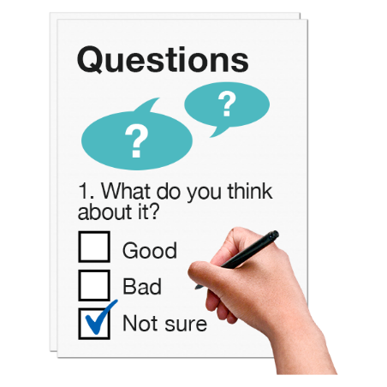

We want to know what you think about changes to the NoWcard for disabled people in Lancashire.

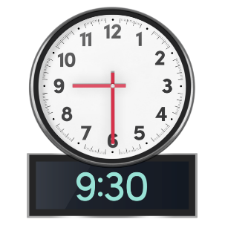

The change is about stopping the £1 fare before 9.30am on weekdays.

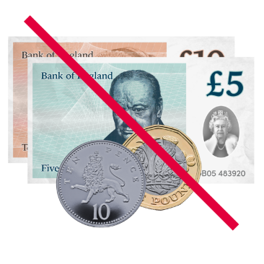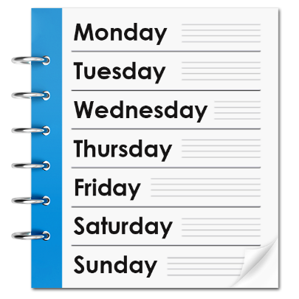The NoWcard lets people travel for free on buses from 9.30am to 11pm on weekdays.

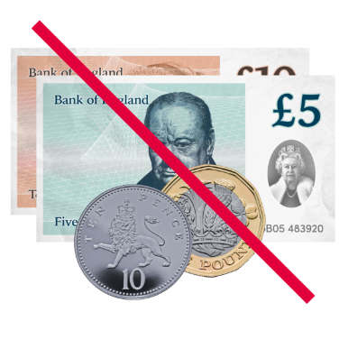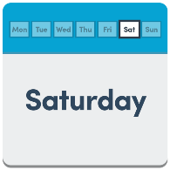

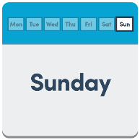It is also free all day on weekends and bank holidays.

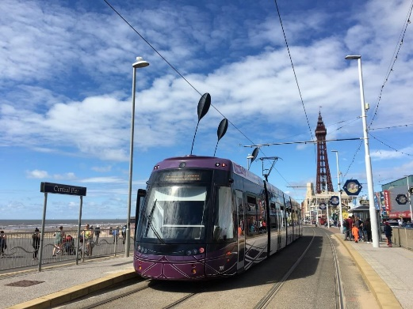

People in Wyre can also travel for free on the Blackpool Tramway with their NoWcard.

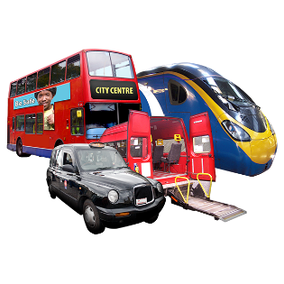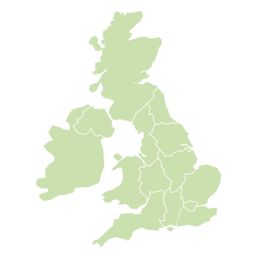

This is part of the national travel scheme.

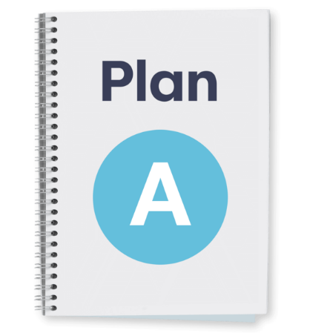

There are no plans to change the free travel times. You can still travel for free during these times.

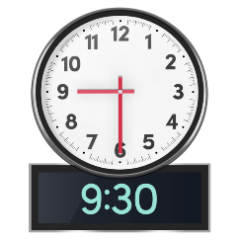

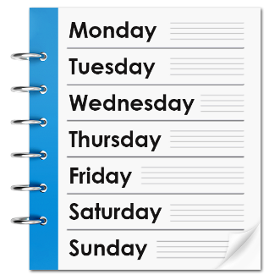Right now, people with a disabled person's NoWcard can pay £1 for bus trips before 9.30am on weekdays.

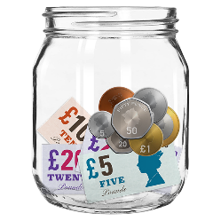We are thinking of a plan to save money over the next two years.

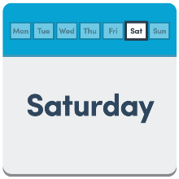

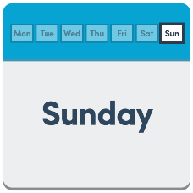One idea is to stop the £1 bus trips before 09:30am on a weekend. This means you will have to pay the normal bus fare. This is £2.

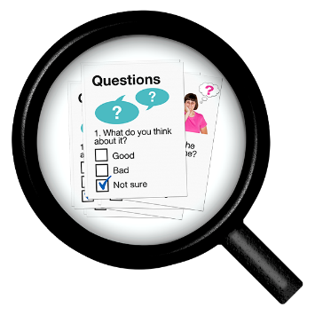

On 23 February 2024, the county council said they want to hear what people think about stopping the extra help.



They want to know your thoughts.

After people share their views, a report will be made.

This report will help the county council decide what to do next.



If you need the questionnaire in a different way, you can call 0300 123 6734.



You can also email [Nowcard@lancashire.gov.uk](mailto:Nowcard@lancashire.gov.uk) for help.

|  |  |
| --- | --- |
| Q1 | **Do you have a Lancashire County Council's NoWcard?** |
|  | *Please select one option only* |
| O | Yes |
| O | No - **GO TO QUESTION 7** |
| O | Don't know - **GO TO QUESTION 7** |

|  |  |
| --- | --- |
| Q2 | **How much do you use your NoWcard?** |
|  | *Please select one option only* |
| O | Every day or most days |
| O | A few times a week |
| O | A few times a month |
| O | Less often |
| O | Never - **GO TO QUESTION 7** |

|  |  |
| --- | --- |
| Q3 | **How much have you used your NoWcard for travel before 9.30am from Monday to Friday?** |
|  | *Please select one option only* |
| O | Every day or most days |
| O | A few times a week |
| O | A few times a month |
| O | Less often |
| O | Never - **GO TO QUESTION 7** |

|  |  |
| --- | --- |
| Q4 | **How much do you usually spend each day on your NoWcard for travel before 9.30am from Monday to Friday?** |
|  | *Please select one option only* |
| O | £1 |
| O | £2 |
| O | £3 |
| O | Don't know |
| Q5 | **Why do you travel before 9.30 am using your Nowcard?** |
|  | *Please tick as many as apply* |
| O | For work |
| O | For caring duties |
| O | To be cared for |
| O | For education |
| O | For medical appointments |
| O | For shopping |
| O | For volunteering |
| O | For leisure |
| O | Other |
| O | None of these |

|  |  |
| --- | --- |
| Q6 | **If 'other' please provide more information** |
|  | *Please write in the box below* |
|  |  |

|  |  |
| --- | --- |
| Q7 | **How much do you agree with the plan to get rid the use of a NoWcard before 9.30am from Monday to Friday?** |
|  | *Please select one option only* |
| O | Strongly agree |
| O | Tend to agree |
| O | Neither agree nor disagree |
| O | Tend to disagree |
| O | Strongly disagree |

|  |  |
| --- | --- |
| Q8 | **Why do you say that?** |
|  | *Please write in the box below* |
|  |  |

|  |  |
| --- | --- |
| Q9 | **If the plan to remove the use of a NoWcard before 9.30am from Monday to Friday was agreed, please tell us how this would affect you.** |
|  | *Please write in the box below* |
|  |  |

|  |  |
| --- | --- |
| Q10 | **If the plan happened, would you still travel by bus/tram?** |
|  | *Please select one option only* |
| O | Yes |
| O | No |
| O | Don't know |
| O | Make the trip by other means |
| O | Not applicable |

|  |  |
| --- | --- |
| Q11 | **What gender are you?** |
|  | *Please select one option only* |
| O | Female |
| O | Male |
| O | Other |
| O | Prefer not to say |

|  |  |
| --- | --- |
| Q12 | **What age group are you in?** |
|  | *Please select one option only* |
| O | 16-18 |
| O | 19 or over |
| O | Prefer not to say |

|  |  |
| --- | --- |
| 13 | **What is your ethnic background?** |
|  | *Please select one option only* |
| O | Asian/Asian British |
| O | Black/African/Caribbean/ Black British |
| O | Mixed/multiple ethnic groups |
| O | White |
| O | Other ethnic group |
| O | Prefer not to say |

|  |  |  |
| --- | --- | --- |
| Q14 | **Do you consider yourself to be a Deaf person or to have a disability?** | |
|  | *Please select one option only* | |
| O | Yes | |
| O | No | |
| O | Prefer not to say | |
| Q15 | **Please tell us which local area you live in. (This is the council named on your bins.)** |
|  | *Please select one option only* |
| O | Burnley Borough Council |
| O | Chorley Council |
| O | Fylde Borough Council |
| O | Hyndburn Borough Council |
| O | Lancaster City Council |
| O | Pendle Borough Council |
| O | Preston City Council |
| O | Ribble Valley Borough Council |
| O | Rossendale Borough Council |
| O | South Ribble Borough Council |
| O | West Lancashire Borough Council |
| O | Wyre Borough Council |
| O | None of these |
| O | Prefer not to say |

**Thank you for completing this questionnaire.**